** University Of Kigali**

**Schools of Computing and IT**

**Computer Science**

**OOP With Java**

**Assignment 2(Group 5):**

**Topic: Hospital Management System Using JAVA GUI frameworks (Swing) and MySQL database (phpMyAdmin)**

**Document:** Technical report

**Team Members:**

|  |  |
| --- | --- |
| FULL NAMES | Reg Numbers |
| Breye Foka Lagloire | **2401000120** |
| Emmanuel Achiengong Dutic | **2401000082** |
| Eric Tuyishime | **2401000633** |
| Moses Monday MALITH | **2401000974** |
| Abdelgabar Elawad | **2401000388** |
| MAKUR MOSES | **2309000056** |
| IRANZI Deborah | **2309000856** |
| Eben-Ezer Ndeingar | **2401000096** |
| Ongiji Paul | **2401000852** |
| Rutagarama Junior Akim | **2401000697** |

**Lecturer: Dr. NTEZIRIZA NKERABAHIZI Josbert**

1. **Project Overview**

**Title**: Hospital Management System

**Platform**: Java (Swing UI) + MySQL

**Development Tools**: Eclipse IDE, MySQL (phpMyAdmin)

**Purpose**: To help managing hospital operations like patient registration, consultations, lab tests, prescriptions, pharmacy dispensing, treatments, and billing — all under one system.

**Users**: Admin, Doctor, Nurse, Lab Technician, Pharmacist, Receptionist, Patient

**2. System Features**

**Authentication System**

Role-based login (username/password), the user enters his or her username and password then is redirected to his or her Dashboard. The process is done so because of the different users profiles and to restrict access to the different patient information.

**Role Dashboards**

Admin Dashboard (manage staff, roles): Add staff and register users to allow them to access the platform and he is the only one able to that.

Reception Dashboard (register patients, billing): represent the reception at the hospitals, It allows to gather patient information and provide the ID of the patient. Also The billing system is managed here where you pay all the treatments and others

Doctor Dashboard (consultations, prescriptions): Examine the patients and can notes the symptoms and ask for exams and prescribe some medicines with notes to the nurses for treatment

Lab Technician Dashboard (input test results): the lab technician can input test results for each patient that is sent to the lab. The results are directly sent to the doctors dashboard.

Pharmacist Dashboard (dispense medicine, manage inventory): The pharmacist is responsible of dealing with medication delivery and inventory management.

Nurse Dashboard (handle treatments): The Nurse Handles the treatments, Iv or Injections and other types, she can comment her observations on the patient reaction to the medicines

**Database Management**

MySQL relational schema with foreign keys

Includes tables like patients, staff, roles, users, inventory, prescriptions, treatments, etc.

**Workflow**

Reception → Doctor Consultation → Lab Test → Final Diagnosis → Pharmacy → Nurse Treatment → Billing

**Data Integrity**

All critical actions are linked with foreign key constraints

Timestamps for audit/history

**3. Technology Stack**

|  |  |
| --- | --- |
| Component | Technology |
| Language | Java (JDK 8+) |
| UI Framework | Java Swing (JFrame) |
| Backend Database | MySQL |
| IDE | Eclipse Luna IDE |
| DB Tool | phpMyAdmin |

**4. Database Design**

**Key Tables:**

* patients(id, name, age, gender, address, phone)
* staff(id, name, role_id, specialization, availability)
* roles(id, name)
* users(id, username, password, role_id)
* consultations(patient_id, doctor_notes, symptoms)
* prescriptions(patient_id, diagnosis, medicines)
* lab_results(patient_id, test_name, result)
* dispensed_medicines(patient_id, medicine_name, quantity, unit_price)
* bills(patient_id, total_amount, payment_method)

Relational Diagram

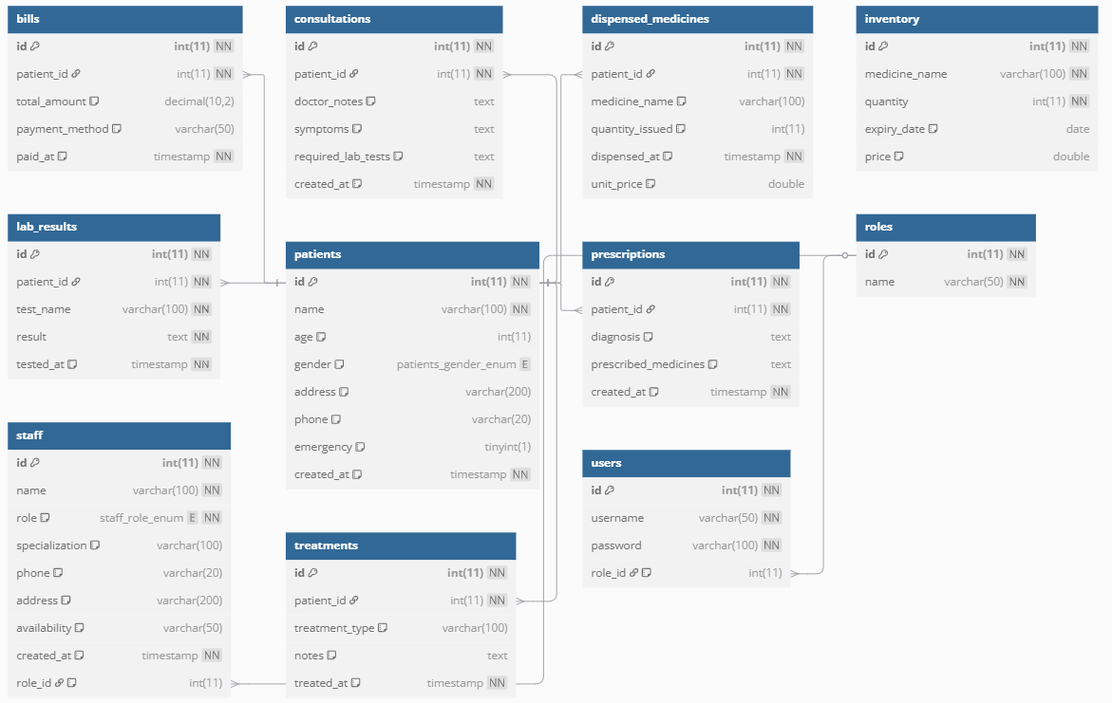

**5. Screenshots**

Login Screen

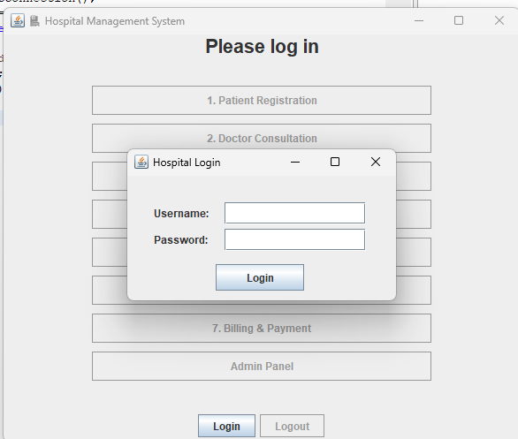

Admin Dashboard

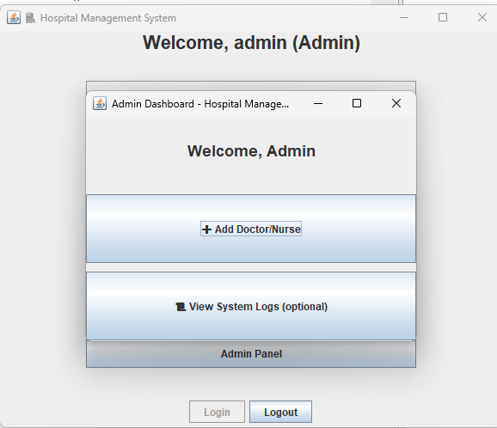

* Staff Management UI

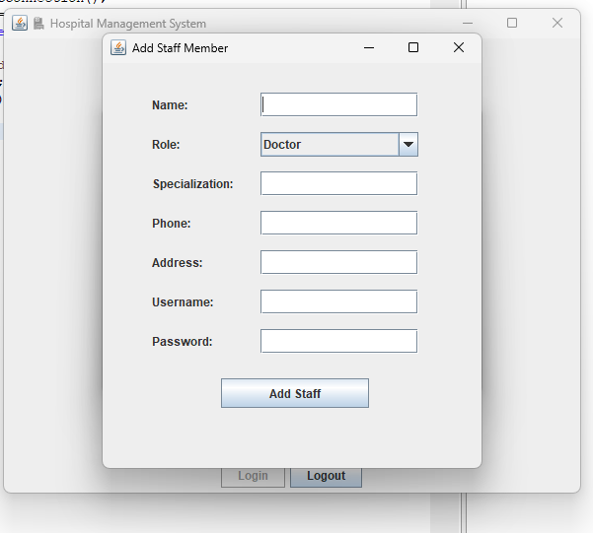

* Patient Registration Form

* Doctor Consultation Form

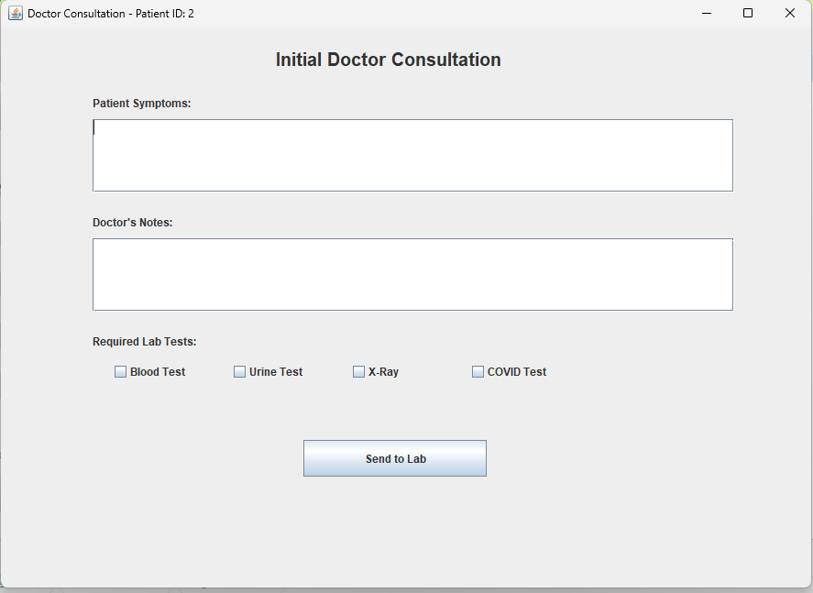

* Lab Result Entry Form

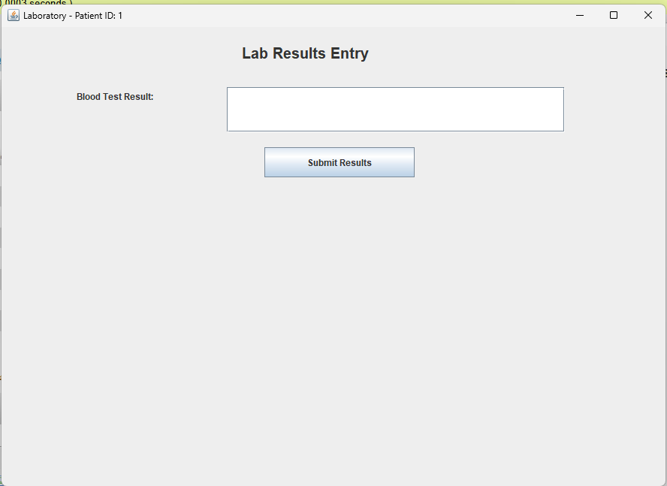

* Prescription UI

* Pharmacy Dispensing UI

* Billing Page

**6. Testing & Validation**

* Manual testing by role: The testing Process consisted of creating different users roles and types to access the different dashboards. Doing so manually and visiting the dashboard and testing the functionalities. Al was correctly working minor bugs and small room for improvement.
* Data validation on inputs: The Data validations on this project was basically making sure data are in correct format and that no required field is Empty using the isEmpty() method on all the fields required.
* Error-handling (e.g., login errors, foreign key mismatches): When encountered an error the System has Try and catch blocks that allows a good error handling process and inform the user of the possible cause of it
* Sample test data populated (RWF currency used): The database was populated with sample data to test the different functionalities.

**7. Challenges Faced**

* Swing UI layout management
* Database foreign key constraints and syncing
* Managing role-based navigation
* Error debugging (e.g., null foreign keys, Enum/column mismatches)

**8. Future Improvements**

* Add password hashing and secure authentication
* Deploy system over LAN for multi-user access
* Export reports (e.g., PDF for bills or test results)
* Mobile-friendly version (JavaFX or web-based)
* Use of ORMs like Hibernate

**9. Conclusion**

The Hospital Management System is a complete simulation of real-life hospital operations using Java and MySQL. It helps automate hospital tasks, reduce paperwork, and increase workflow accuracy through structured software modules and a relational database.